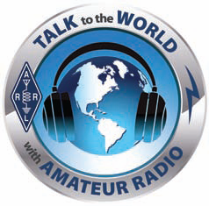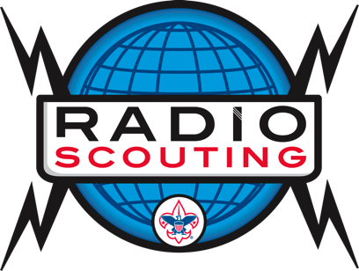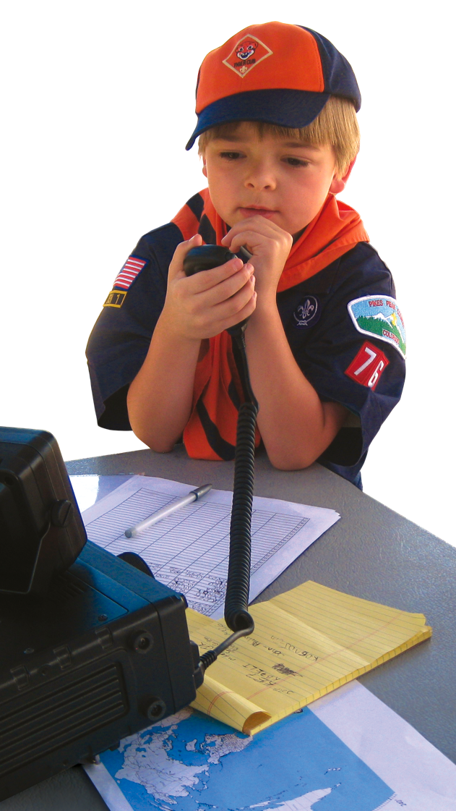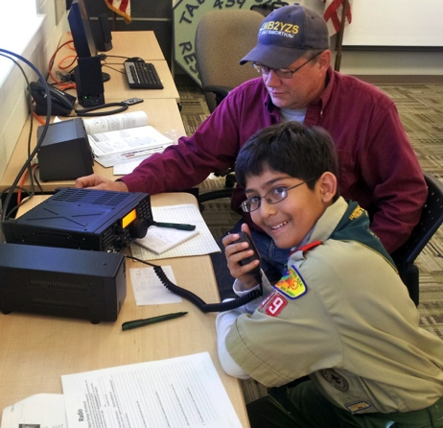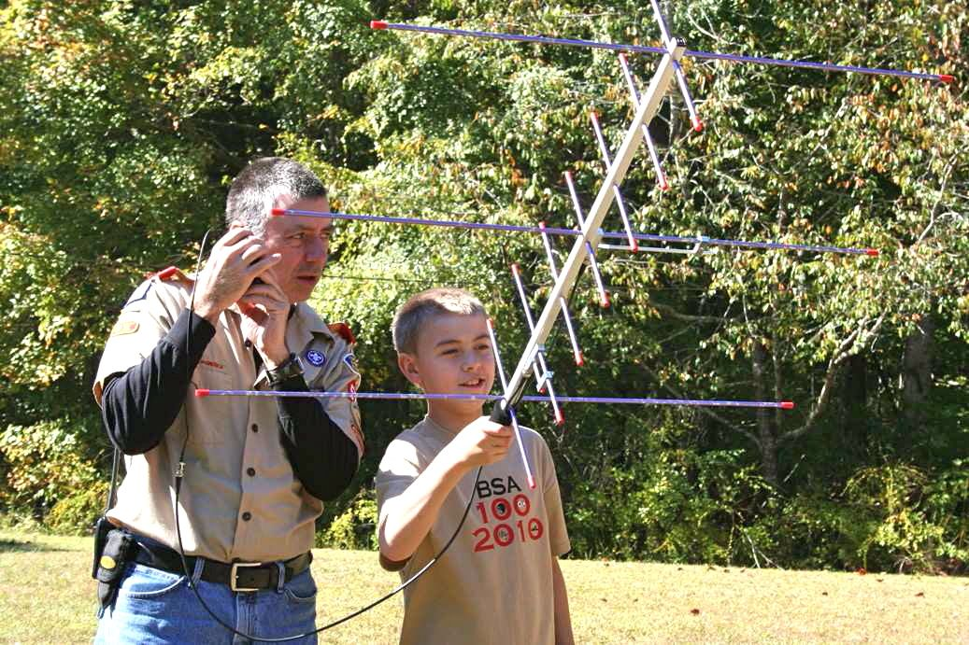

## Next Steps:

Find your local Scout Council:

<http://scouting.org/localcouncillocator.aspx>

or <http://www.girlscouts.org/councilfinder>

Call the Scout Council to get the name and phone of your local District Chairman. He can link you with local units.

* Introduce yourself and your interests.
* Hold a Ham club open house for Scouts.
* Get registered with a Unit or District.
* Become a Radio Merit Badge Counselor.
* Promote radio based Scout activities throughout the entire year.

The best sources of Radio Scouting information are at three main websites ---

Boy Scouts of America’s Jamboree on the Air webpages:

<http://www.scouting.org/jota>

ARRL web pages on Scouting and on Jamboree on the Air:

<http://www.arrl.org/amateur-radio-and-scouting>

<http://www.arrl.org/jamboree-on-the-air-jota>

K2BSA Amateur Radio Association, the Radio Scouting organization:

<http://www.k2bsa.net>

You can also scan this QR code to reach a page that has compiled several Radio Scouting resources:

<http://www.k2bsa.net/links>

## More Information

Share your love of ham radio with today’s youth through Scouting

Mentoring the Next Generation of Hams

##### **Promote Jamboree on the Air**

* Third full weekend in October
* Offer to set up a portable station at a Scout Camporee or Camp
* Have an Open House at your club station
* Set up EchoLink stations to assure world-wide contacts

Info at <http://www.scouting.org/jota>

##### **Teach the Radio Merit Badge**

* Register as a Merit Badge Counselor
* Badge is about half of a Tech exam
* Can be taught in 4 - 5 hours
* Common requirements on radio terms, equipment, spectrum, propagation, safety
* Offer a follow-up Tech License course

Teaching materials are online at

http://www.scouting.org/jota/radio_merit_badge.aspx

##### **Introduce Morse Code**

Scouting has introduced a Morse Code Interpreter Strip that has generated a great deal of interest from Scouts. See the requirements and resources at

<http://www.k2bsa.net/morse-code/>

##### **Tips**

* Promote events face-to-face at unit meetings and “District Roundtables”. Scouts already have lots of activities.
* Best to have ham radio as a component of a larger event, such as a Camporee or Summer Camp.
* Expand the scope beyond just talking on HF; include FRS Radios, Fox Hunts, ISS, Message Relay, NOAA Weather Radio, GPS, APRS, Satellite, Repeaters, etc.
* Tie your events and ham radio activities into the STEM initiatives: Science, Technology, Engineering, and Math.

##### **Amateur Radio Operator Rating Strip**

Scouting has introduced the Amateur Radio Operator Rating Strip for uniform wear by youth and adults who are licensed amateur radio operators. This is a perfect next step after the Radio Merit Badge and provides another patch for their uniforms, always a big deal for Scouts! Learn more at

<http://www.k2bsa.net/operator-rating/>

##### **Future Ham/Scout Events**

* ARRL Kids Day, January and June. <http://www.arrl.org/kids-day>
* ARRL Field Day, fourth full weekend in June. <http://www.arrl.org/field-day>
* Jamboree on the Air, third full weekend in October. Lots of information and resources at <http://www.scouting.org/jota>

##### ***Get involved with Scouting and help youth engage with the fun, technology, and magic of Amateur Radio!***

Hams and Scouting Help Each Other Grow!

# **Activities You Can Offer**

*Scouting is an ideal way to introduce amateur radio to the next generation of hams!*

###### Jamboree On The Air (JOTA)

###### Summer Camp Ham Stations

###### Camp-O-Ree, Scout-O-Rama

###### Radio Merit Badge Classes

###### Field Day Joint Event

###### “Radio Daze”

###### Backpacking Support

###### Fox Hunts

###### National Jamboree Support

###### Public Service Communications