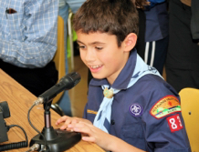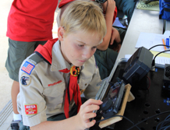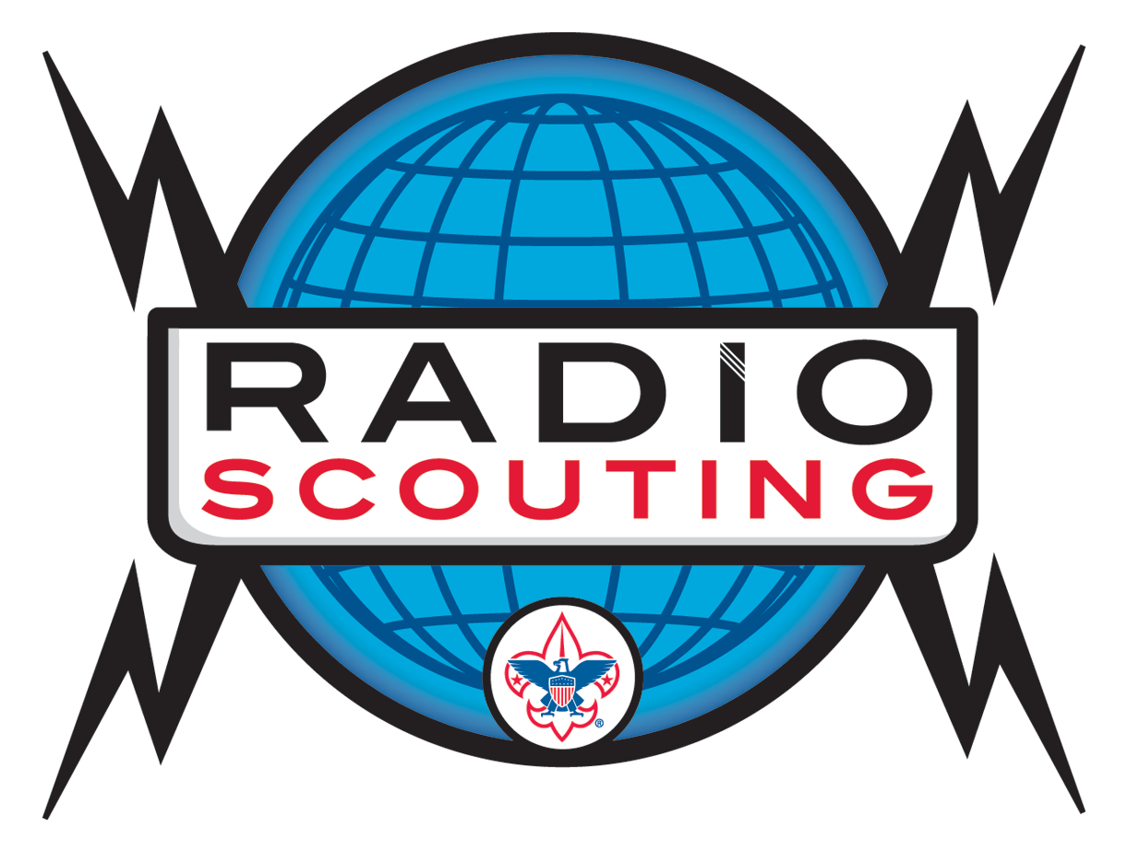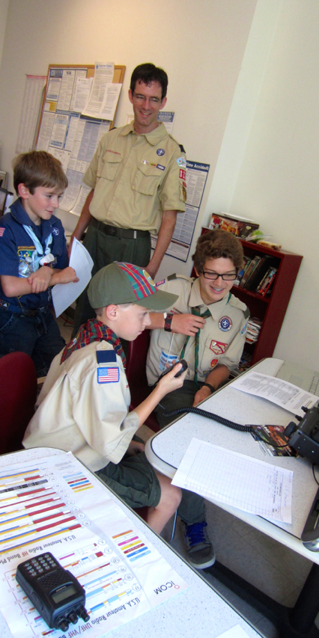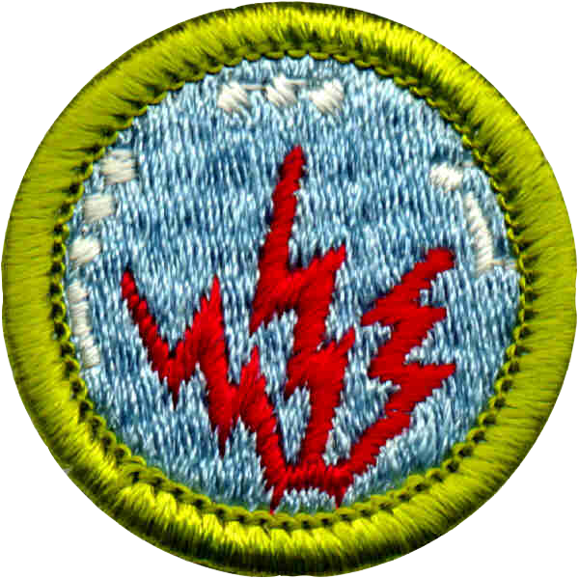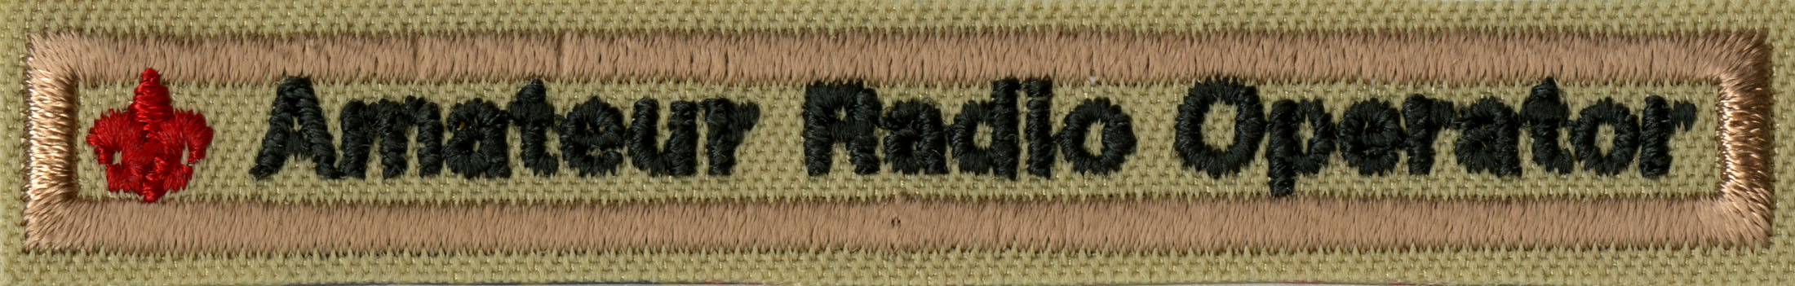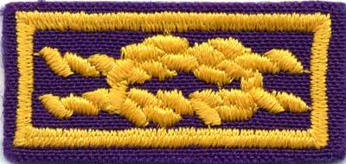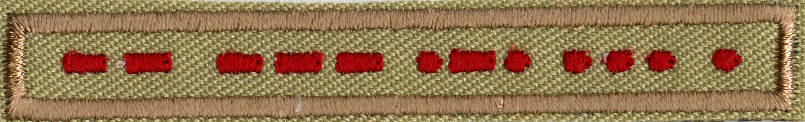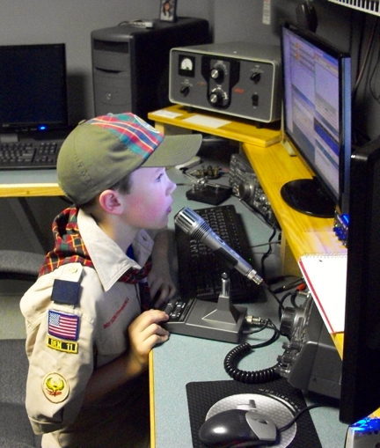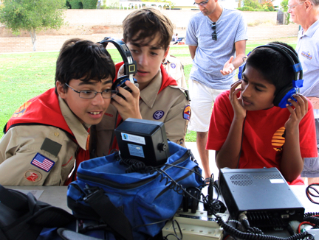

**Technology. Fun. Magic.**

Amateur Radio in Scouting

**Radio Scouting**

Devoted to extending the reach of amateur radio within Scouting

## Amateur Radio

Amateur Radio is an ideal way to introduce technology to Scouts at every age level.

Activities include:

Jamboree on the Air

Radio Merit Badge

Summer Camp Stations

Camporee Stations

ARDF – Foxhunting

STEM Programs

National Jamboree

**For More Information:**

**K2BSA Amateur Radio Association**

**www.K2BSA.net**

**Boy Scouts Jamboree on the Air**

**www.scouting.org/jota**

**ARRL**

**www.arrl.org/amateur-radio-and-scouting**

**www.arrl.org/jamboree-on-the-air-jota**

**Radio Merit Badge**

6,000+ Scouts

earn it every year.

**ARRL Service to Scouting Award**

Awarded to adult leaders who have made a difference with Radio Scouting in their units, districts, and councils. Awarded by ARRL.

**Amateur Radio Operator Rating Strip**

Youth and adults who hold an amateur radio license can wear this patch. Great incentive for license classes following Radio Merit Badge.

**Jamboree on the Air — JOTA**

The largest Scouting event in the world with 1 million participants, nearly 20,000 amateur radio operators, and 11,000+ stations. It happens the third weekend in October.

**Morse Code Interpreter Strip**

Send and receive 5 wpm, earn this patch.

Amateur radio provides an exciting and engaging introduction to technology, the fun of communicating with other Scouts, and the magic of long distance communication.

There is an extremely strong amateur radio program within Scouting from Jamboree on the Air – the largest Scouting event in the world – to earning the Radio Merit Badge, qualifying for the Morse Code Interpreter Strip, as well as the Amateur Radio Operator Rating Strip.

# Technology. Fun. Magic.